
For WBCS Examination
2nd Oct 2026
Daily Current Affairs for WBCS
2nd October 2026

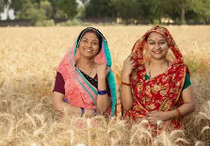
Awards and Honours
- Female Farmer Worker Conference: Women farmers were honoured for contributions to cow-based organic farming, indigenous seed conservation, animal husbandry and food processing.
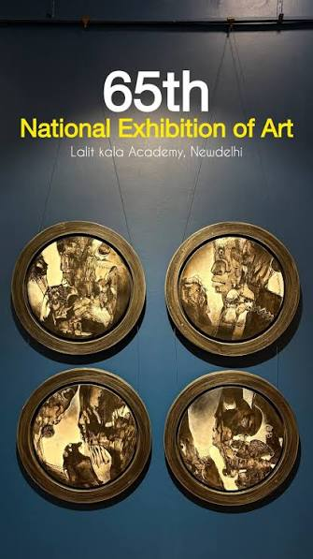
- 65th National Exhibition of Art: Lalit Kala Akademi announced 20 national awards in painting, sculpture, printmaking and drawing at Rabindra Bhavan, New Delhi.

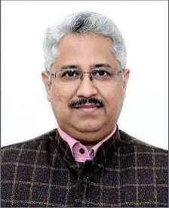
Appointments and Persons in the News
- CBSE Chairperson: Mandeep K. Bhandari was appointed Chairperson of the Central Board of Secondary Education.

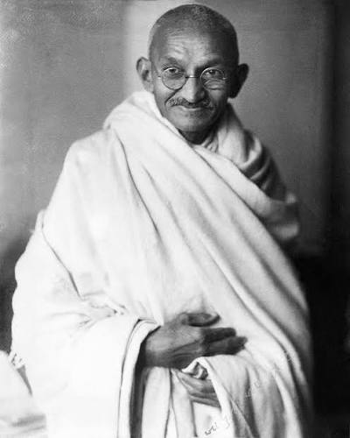
- Mahatma Gandhi Jayanti: Gandhi’s 157th birth anniversary was observed nationwide on 2 October.

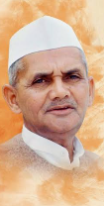
- Lal Bahadur Shastri Jayanti: Shastri was remembered for the slogan “Jai Jawan, Jai Kisan” and his contributions to national security and agricultural self-reliance.

Government Schemes and Policies
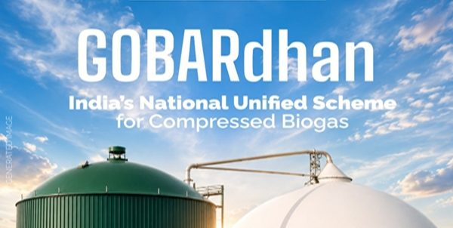
- GOBARdhan Central Sector Scheme: Launched with an outlay of ₹23,731 crore for 2026–27 to 2035–36 to expand commercial Compressed Biogas production and pipeline integration.
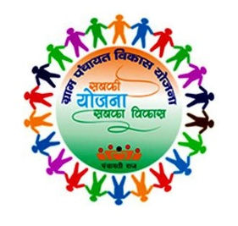
People’s Plan Campaign 2026–27: Launched under “Sabki Yojana, Sabka Vikas”, with over 2.42 lakh Special Gram Sabhas preparing Panchayat Development Plans for 2027–28.

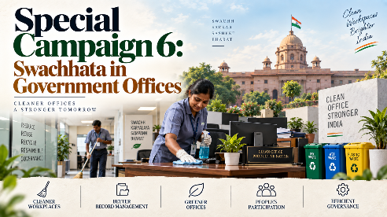
- Special Campaign 6: Scheduled for 2–31 October 2026, focusing on electronic waste segregation, digital record management and reducing administrative pendency.
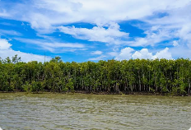

- National Coastal Mission 2.0: The Ministry of Environment, Forest and Climate Change released guidelines for the ₹767 crore scheme covering nine coastal States and four Union Territories.
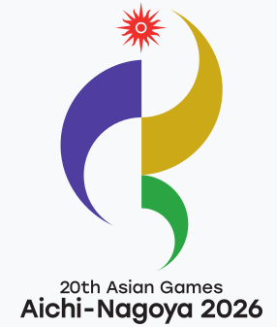
Sports and Games
- Asian Games 2026 — Women’s Hockey: India defeated China 1–0 to win gold, according to the provided report.
- Asian Games 2026 — Kabaddi: India won gold medals in both men’s and women’s kabaddi.
- Men’s Marathon: Indian athlete Sawan Barwal won silver.
- Women’s Sailing: Harshita Tomar and Shital Verma won bronze in the skiff event, while Nethra Kumanan secured bronze in the dinghy event.
- Asian Games Medal Tally: India had reportedly secured 76 medals, including 16 golds, by the evening of 2 October, ranking fifth overall.

Science, Space and Technology
- Indigenous Carbon Fibre Facility: The Council of Scientific and Industrial Research unveiled a domestic high-strength carbon fibre manufacturing facility to reduce strategic aerospace and defence imports.
- Lightweight Bulletproof Glass: The Defence Research and Development Organisation and CSIR-Central Glass and Ceramic Research Institute launched a ₹50 crore project to develop multi-shot-resistant bulletproof glass using glass-ceramic technology and nanocrystals.
- CSIR–NEERI Foundation Day: The National Environmental Engineering Research Institute celebrated its 85th Foundation Day in Nagpur, highlighting space exploration and future Chandrayaan missions.
- Programmable Central Bank Digital Currency: Bank of India introduced programmable digital rupee payments for education, allowances and other specified uses.

Summits, Legislation and International Affairs
- Uniform Civil Code: Gujarat became the second Indian State after Uttarakhand to enact a Uniform Civil Code.
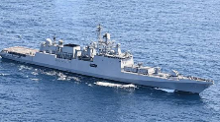
- G20 Trade Ministers’ Meeting: Concluded in Milwaukee, United States, where Commerce Minister Piyush Goyal advocated World Trade Organization-compliant measures against supply chain distortions and forced labour.
- Indo-Pacific Economic Framework: The Clean Economy Agreement entered into force to mobilise clean energy and decarbonisation investments.
- INS Trishul: The Indian Navy’s guided-missile stealth frigate arrived in Valencia, Spain, for an overseas engagement.

Important Days
- Mahatma Gandhi Jayanti — 2 October: Commemorates Gandhi’s birth anniversary and highlights Swadeshi, non-violence and cleanliness.
- International Day of Non-Violence — 2 October: Observed under United Nations General Assembly Resolution A/RES/61/271.
- Lal Bahadur Shastri Jayanti — 2 October: Marks the birth anniversary of India’s second Prime Minister.
- Swachh Bharat Diwas — 2 October: Observed through Gram Sabha cleanliness drives and tree plantation under “Ek Ped Maa Ke Naam”.

Miscellaneous
- Official Map of Ladakh: The Survey of India standardised 28 geographical feature names, including Atisha Giri, Kanishka Peak, Zorawar Peak, Chapchingal Pass, Parpik Glacier and Guru Rinpoche Lake.
- Jawahar Dweep: Mumbai Harbour’s Jawahar Dweep, also known as Butcher Island, became India’s first single-use plastic-free oil terminal, alongside new oil spill response facilities.
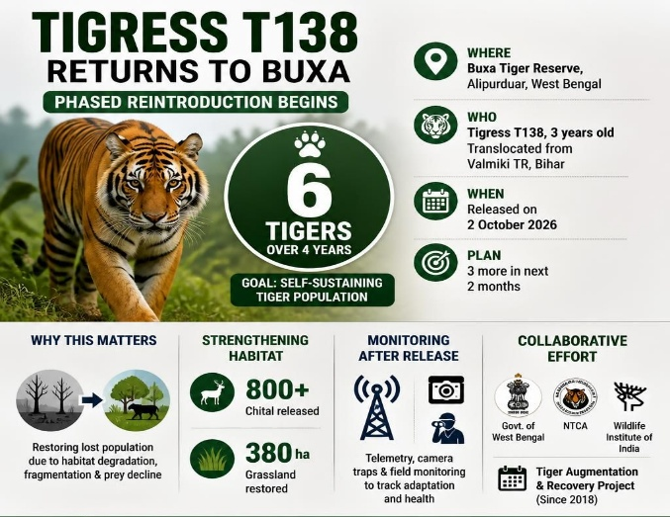
- Dark Sky Park: Pench Tiger Reserve was certified as India’s first Dark Sky Park to help curb light pollution.
- Dharavi Experience Centre: A 22,500-square-foot centre featuring three-dimensional walkthroughs and sample homes opened in Mumbai under the Dharavi Redevelopment Project.
- Marshall Islands: A United Nations Human Rights Office report urged the United States to address health and nuclear waste concerns linked to 67 nuclear tests, including the structural integrity of the Runit Dome.

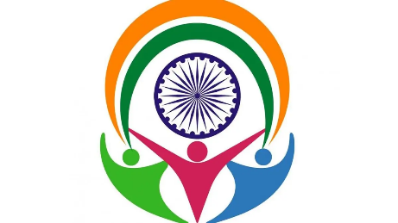
West Bengal Current Affairs
- Buxa Tiger Reserve: Union Environment Minister Bhupender Yadav released tigress T138, translocated from Bihar’s Valmiki Tiger Reserve, under the Tiger Reintroduction Programme.
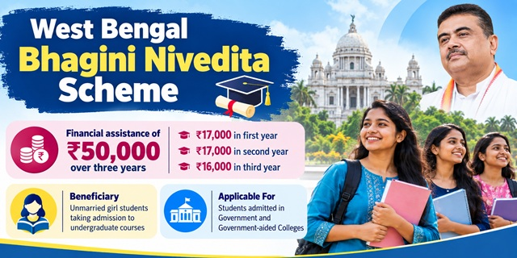
- Annapurna Yojana: The fourth instalment of ₹3,000 monthly direct bank transfers was released to nearly 15 million women in West Bengal.

- Pravasi Bharatiya Diwas 2027: Kolkata is scheduled to host the 19th convention from 7–9 January 2027, organised by the Ministry of External Affairs and the West Bengal Government.
- Bhagini Nibedita Scheme: A West Bengal government initiative announced to provide ₹50,000 over three years to unmarried women pursuing higher education.

***

